Logistic Regression
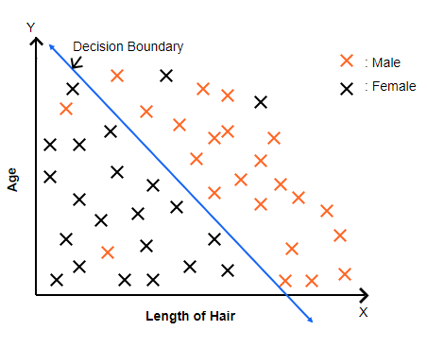
Logistic Regression is a supervised machine learning algorithm for classification, usually binary (0 or 1). Instead of predicting a continuous value, it predicts the probability of a class:
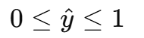
We have features $f_{1},f_{2},...,f_{d}$ (let’s denote as vector $f$) and parameters $w$ (weight vector).
The linear combination of features is:
We map $z$ to a probability using the sigmoid function:
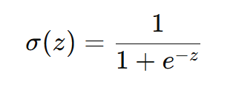
So, the predicted probability that $y=1$ is:
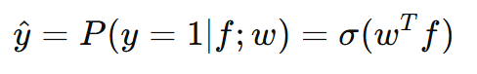

Cost Function (Binary Cross-Entropy)
The loss for one example is:
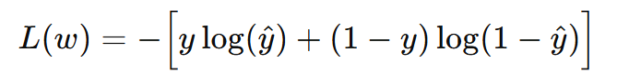
For n examples, the cost function $J(w)$ is:
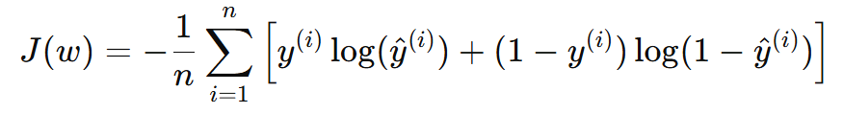
Gradient of the Cost Function
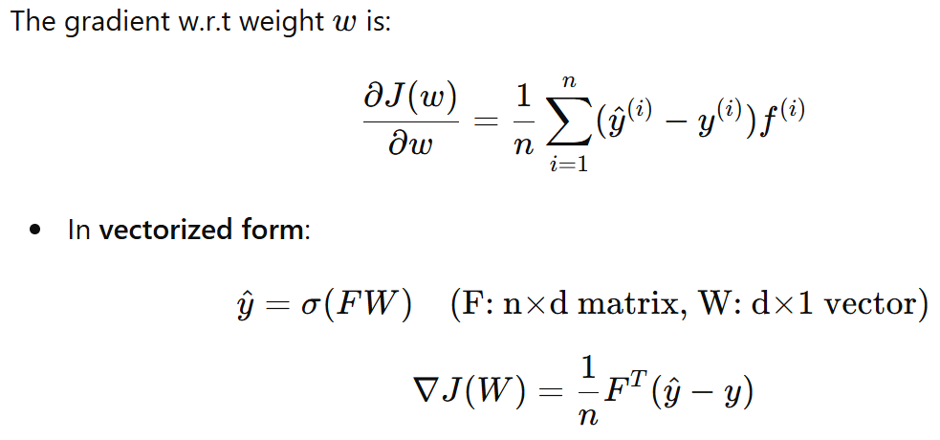
Gradient Descent Update
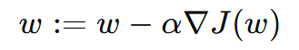
Decision Boundary
